Jordan Mitchell

1/29/2025

Professor Chan

Assignment: UI Design

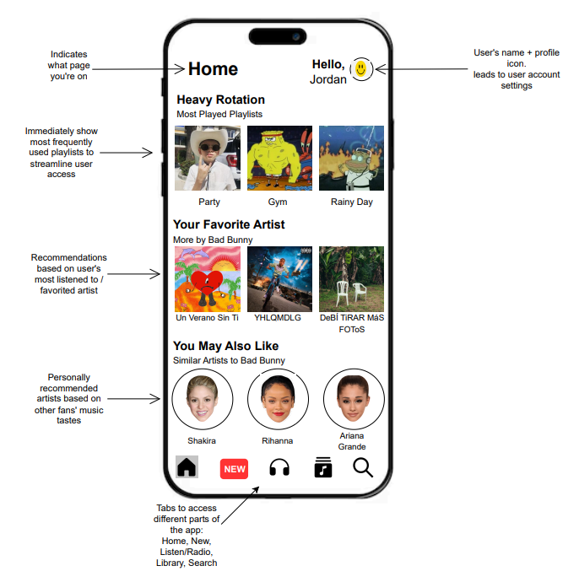

For this assignment, I chose to redesign Apple Music's Home screen because I felt that the current layout can be overwhelming. There are too many playlists and radio options, each with flashy colors competing for attention. My main goal was to simplify the interface while keeping essential features easily accessible. I wanted to create a more organized and user-friendly experience where users could quickly find their most-used playlists and discover new content from their favorite artists or genres without feeling overloaded.   
 One of the biggest issues I noticed was that radio stations seemed underutilized, yet they took up significant space in the UI. At the same time, the existing "New" tab icon didn’t clearly communicate its purpose, and the original design didn’t actively encourage users to check for updates. With these issues in mind, my focus was on improving clarity, feature placement, and visual indicators to make interactions feel more intuitive and efficient.

**Key Changes**

To address these issues, I made multiple adjustments to improve navigation and usability.

* Changed Radio Tab: I moved the radio feature into a new "Listen" tab instead of keeping it as both a prominent section on the home screen and its own tab. This was based on my observation that radio was underused while taking up unnecessary space. By placing it within the Listen tab, users who are actively looking for radio content can still access it easily, but it no longer clutters the home screen experience.
* Updated New Icon: The original “New” icon was a generic grid of four squares, which I found didn’t effectively draw attention to new releases. I redesigned it to be bolder and eye catching, encouraging users to check for fresh content. Additionally, the icon turns red when there are new updates, providing a quick visual cue that doesn’t require notifications. This change improves discovery and gives a more immediate way to find newly released music.
* Changed Button “Hover”: I placed a shadow effect over the selected Home button, creating an “elevated” look that indicates the user’s current location within the app. This small but helpful change enhances navigation clarity, making it easier for users to recognize which tab they’re in with a quick glance.
* Improved Personalized Recommendations: The section states similar artists to the user's favorites to make recommendations clearer. This ensures that users understand the connection between their favorite music and the suggested content, adding a level of personalization and new music discovery. I also included a separate section for content by a user’s favorite artist, allowing users to quickly browse additional songs, albums, and content from the artists they already enjoy. This reduces the need to manually search for more music and makes finding their favorite artists’ latest or even past releases much more convenient.

These adjustments will help condense the interface while keeping key features accessible, making the overall experience more engaging and well structured.

**UI Justification**

My redesign follows UI best practices by focusing on simplicity, accessibility, and visual hierarchy to create the best possible experience for users.

* Reduced Clutter + Improved Navigation: Moving the radio components into the Listen tab removes unnecessary distractions from the home screen, keeping content concise while keeping radio accessible. The Home button shadow effect also helps users easily recognize their current location within the app. Originally, the icons would highlight in red, but as I've changed the “New” tab's icon, this is the alternative that still ensures visibility.
* Improved Engagement: The redesigned "New" icon encourages users to explore fresh music more often by using a color change as a visual cue. This small but effective update makes finding new releases faster and more convenient by notifying users that there is something new to see. As it currently stands, the tab does nothing to indicate that there is something recent that may intrigue you. If you are someone without adequate amounts of time to browse, this is a convenient way to help you stay up to date.
* Better Personalization: Having the artist recommendation section that says "Similar Artists to [Insert Favorite Artist]" makes it more intuitive and aligned with user expectations. Additionally, the "More by Your Favorite Artist" section gives users a direct way to explore more content they are likely to play without searching manually. I've also included a greeting message with the user's name at the top next to the profile icon to add a personalized touch.
* Visual Hierarchy: The updated layout prioritizes the most relevant content, such as regularly played playlists and artist recommendations, making it easier for users to find what they need without excessively looking around. The use of bolded sections and spacing maintains clarity and leaves no ambiguity as to their purpose. Currently, Apple has multiple sections all varying in size, color, and shape, making the screen feel jumbled.

By incorporating these practices, my redesign creates a simpler, user friendly, and engaging Apple Music experience that better serves user needs.

**Final Thoughts**

The redesign process allowed me to take a critical stance on an app's UI and consider how small changes can have a larger impact on usability. Drawing from my own experienced frustrations, as well as that of others from reviews, I was able to determine the areas that could be improved upon. By focusing on navigation clarity, feature organization, and visibility, I was able to simplify the Apple Music interface while keeping central features easily accessible.

One of the biggest takeaways from this was understanding the importance of visual hierarchy and how the arrangement of information can improve the overall experience. Additionally, designing interactive elements, like the elevated tab buttons and dynamic ‘New’ icon, reinforced my knowledge of the importance of user engagement cues in mobile UI. I think of when touchscreen phones began adding haptic feedback to indicate you had properly interacted with an input. For example, before smart phones, many phones had keyboards/pads that clicked and that served as feedback, but touchscreens are all one surface. That small yet major change is a big quality of life improvement that many users enjoy.

If I had more time, I would explore additional refinements such as customization options for the home screen layout, allowing users to personalize their experience even further. I think the option to arrange the information in a manner that suits each person is a viable option that can let you drag and drop, resize, and even remove certain features from the screen. Overall, this assignment strengthened my ability to analyze existing patterns and apply design principles to make functional and effective changes.